Lab 10
Natnael Kebede
Section 1
- Screen capture showing newly configured domain password policy settings
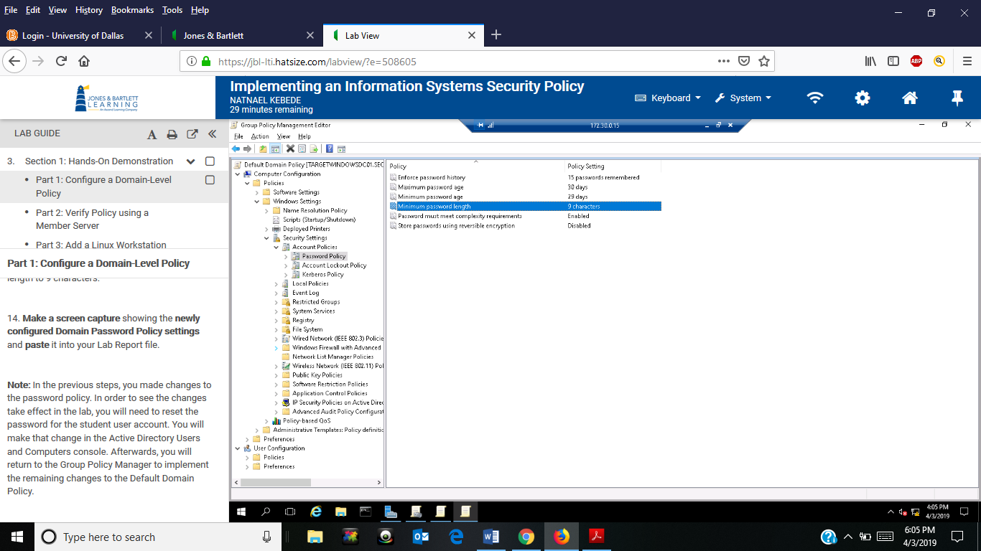

- Screen capture showing the newely configured account lockout policy
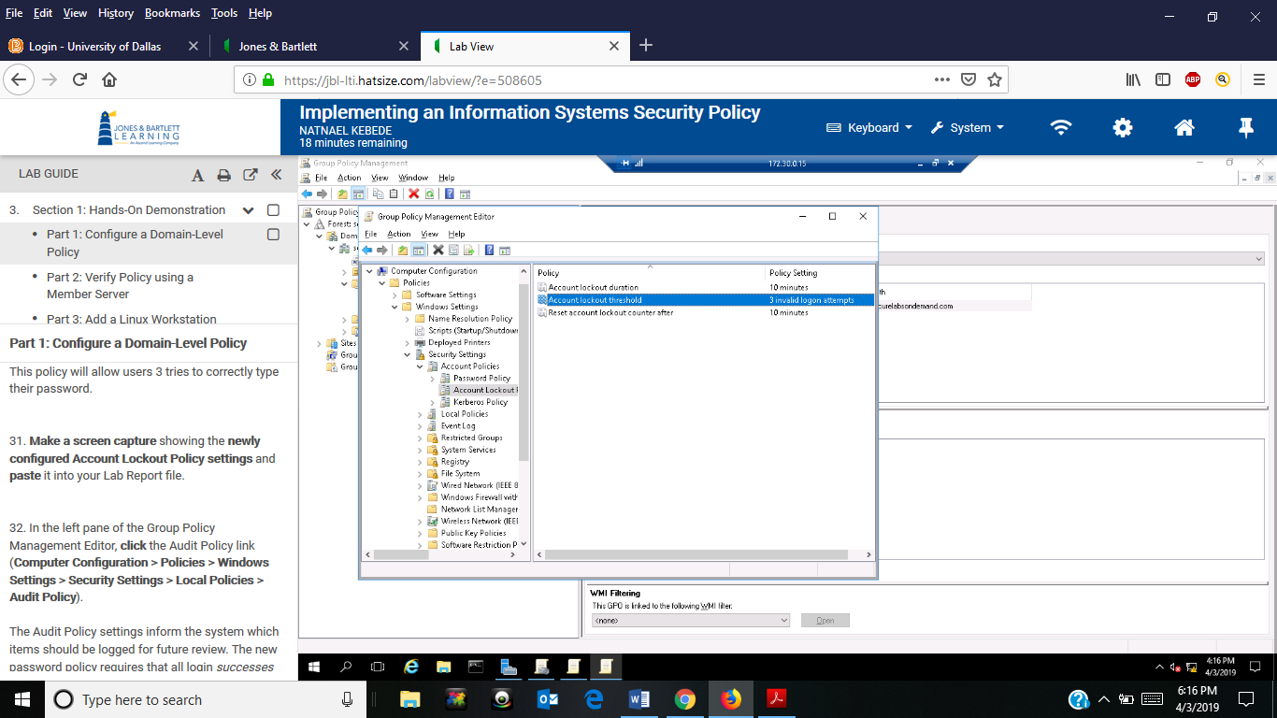
- Screen capture showing student user account logged on to TargetWindowsMem03
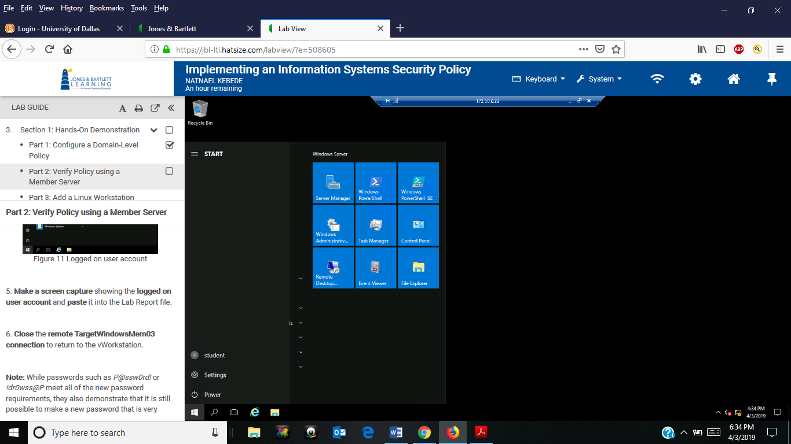

- Screen capture showing Administrator account logged on to TargetLinux
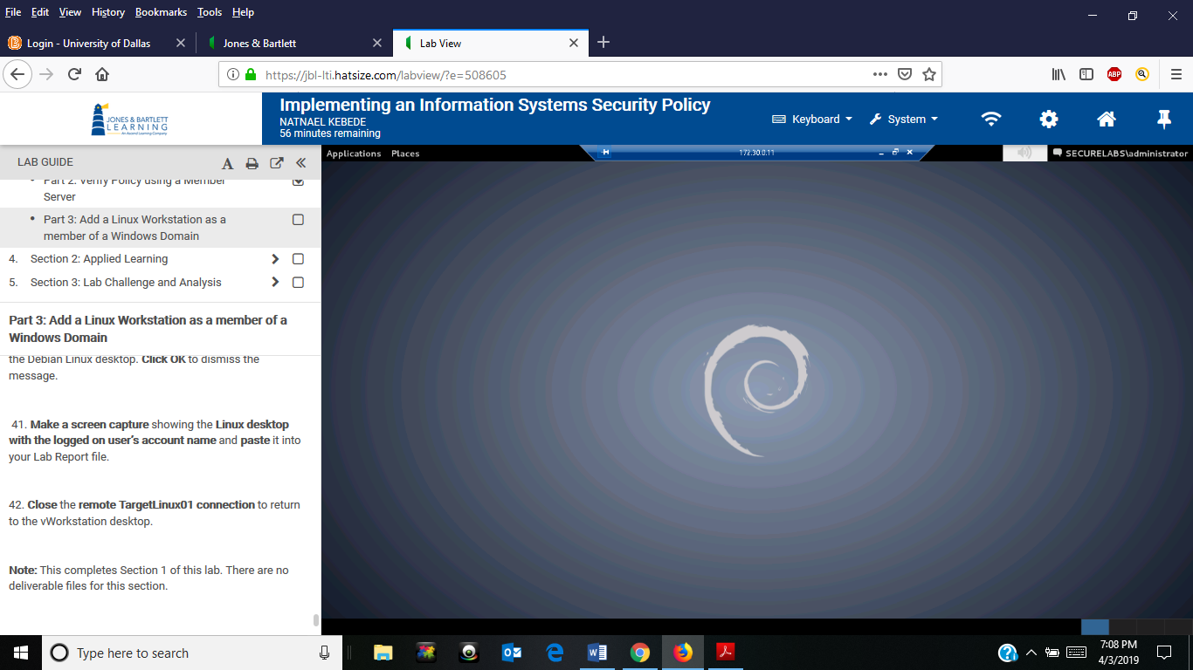

Section 2
- Screen capture showing newly configured domain password policy settings
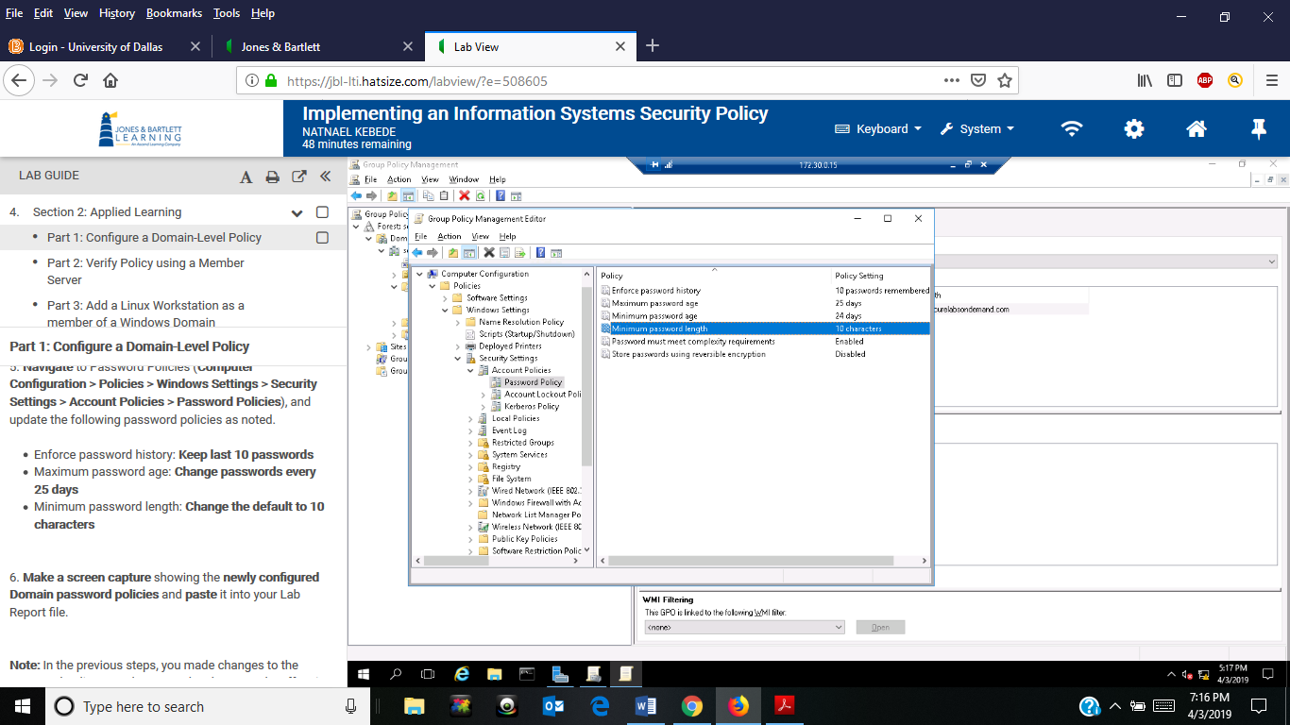

- Screen capture showing the newely configured account lockout policy
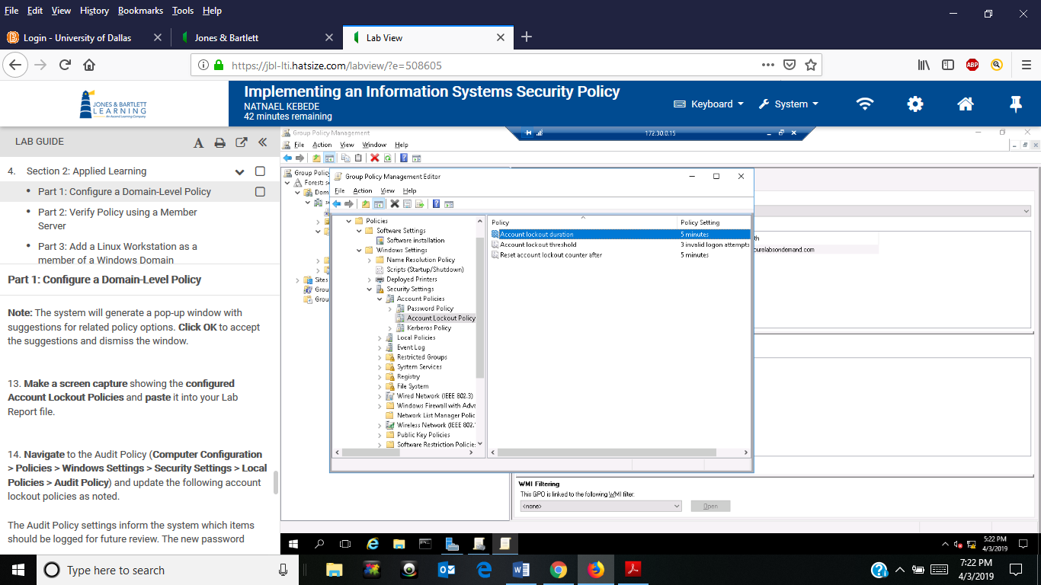

- Screen capture showing student user account logged on to TargetWindowsMem03
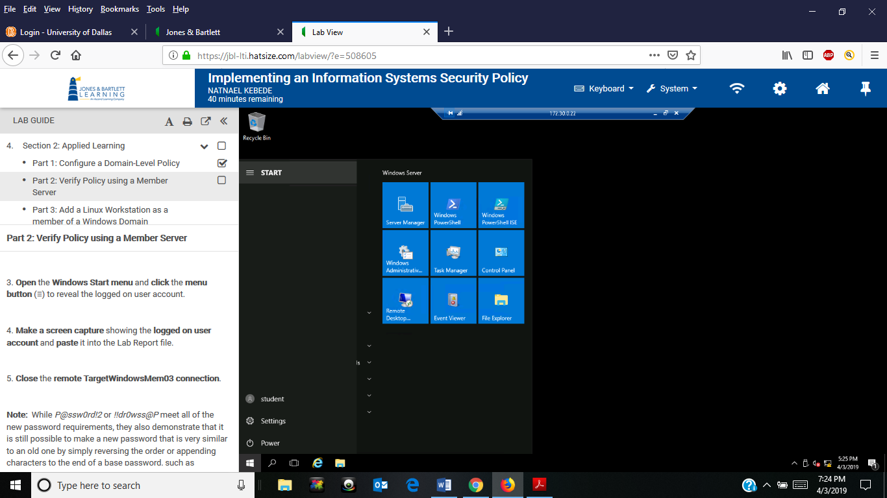

- Screen capture showing Administrator account logged on to TargetLinux
